***Harvard Public Health Review* Submission Preparation Guidelines**

**About the *Harvard Public Health Review* (*HPHR*)**The Harvard Public Health Review (HPHR) is a peer-reviewed public health journal that has grown exponentially since launching in its current form, in 2014.  We are currently indexed in [JSTOR](https://www.jstor.org/journal/harvpublhealrevi).HPHR invites submissions from students, faculty, researchers, and others across academic disciplines, as well as from members of the general public that speak to the Journal’s [mission and vision](https://harvardpublichealthreview.org/about/) and elucidate pertinent and timely public health issues within an evidence-based and health equity framework.

To ensure a dynamic showcase for contributors’ diverse research interests, talents, and creativity, HPHR seeks a range of materials. The following sections provide detailed information about the submission process.

**Who May Submit?**   
Submissions are welcome from students, faculty, and community members across public heath disciplines. Submissions must elucidate pertinent and timely public health issues within an evidence-based and health equity framework.   
  
**Questions?**   
Email questions to [editorial@harvardpublichealthreview.org](mailto:editorial@harvardpublichealthreview.org). Please do not email submissions or pitches for submissions.

**Submission Overview**  
The submission process involves a three step process:

1. **Identifying your piece’s submission type and downloading the appropriate template.**
2. **Preparing your submission according to *HPHR* guidelines**, detailed below and in the template.
3. **Uploading your submission to HPHR’s editorial platform, Scholastica.** Emailed submissions, as well as submission pitches/inquiries, will not be considered for publication. **Step-by-step instructions are available here**: [HPHR.org/submit-manuscripts-scholastica/](https://HPHRorg/submit-manuscripts-scholastica/).

**Submissions that do not conform to these guidelines will not be considered for publication.**

**Submissions Types***HPHR* currently accepts the following types of pieces in response to its [**Calls for Submissions**](https://harvardpublichealthreview.org/current-calls-for-submissions/): 

1. **Original Research Articles** describe the results of original research of public health importance. Preferred length is**3,000** words max (excluding References, Figures, and Tables). Longer submissions considered on case-by-case basis.
2. **Review Articles** may be systematic (with or without meta-analysis) or narrative, and must address a specific question or issue relevant to public health. Preferred length is **500-3,000** words (excluding References, Figures, and Tables).
3. **Research Letters** are brief articles detailing original research in progress that are **750** words or less (excluding References, Figures, and Tables).
4. **Commentaries** address public health issues written from an evidence-based perspective. Point-Counterpoints are often solicited special editorials on a specific public health issue from opposing vantage points or responses to previously published HPHR articles. Preferred length of these submissions is **500-3,000 words** (excluding References, Figures, and Tables).
5. **Atypical Articles** are unique, creative articles (such as research protocols, essays, poems, policy memos, ethical treatises, etc.) related to the field of public health. These pieces typically are no more than **1,000 words** (excluding References, Figures, and Tables).
6. **Electronic Media** encompass recordings of interviews, editorials, and so on. It also includes **HPHR Author Insight** **videos** from accepted authors. Pieces must be accompanied by a description of **200-300 words**. Authors are responsible for obtaining all reprint permissions. Copies of release forms may be requested prior to publishing images and footage of identifiable persons.

**Document Format**

Submissions must conform to the following:

* Use at least 11 pt Times New Roman font.
* Submit your article file using Microsoft Word (i.e., .doc or .docx file)
* Number all pages.
* Authors are responsible for securing rights as necessary to reproduce previously published images, tables, and figures and ensuring that they are credited appropriately where applicable.
* **DO NOT** submit manuscripts with line numbers
* **DO NOT** submit PDFs or Google doc links.

**Language**

HPHR requires non-discriminatory language to be used at all times. Defamatory language of any kind directed toward persons and/or institutions is not permitted. This includes any and all terms that commonly considered sexist, heterosexist, racist, homophobic, transphobic, and xenophobic.

**Figures**

Figures should be configured as follows:

* Figures are to be placed on separate pages of the article file with legends placed below each figure.
* Figures should be at least 300 DPI, submitted as JPEG, PNG, EPS, or SVG files.
* You may submit video or GIFs as well.
* Figures ideally should be submitted with a transparent background.
* Figures should be titled consecutively according to the order they appear in the text.
* Titles are to appear above the figure, in bold, Times New Roman, 12 point font.
* Legends are to appear directly after the image, single-spaced, in Times New Roman, 12 pt font.
* Titles and legends should NOT be part of the image, but inserted as text in the document, above and below the figure image, respectively.
* Text within figures should be single-spaced, in Times New Roman, 10 point font.

**Tables**

Tables should be created in Word and configured as follows:

* Tables are to be placed at the end of the submission, as indicated in the template.
* Tables should be created using Word (please do not submit them as images).
* Tables are to be numbered consecutively according to the order of citation in the text.
* Titles are to be set above the table in bold Times New Roman, 12 pt font.
* Table text and data are to be set in Times New Roman, 10 pt font, single space.
* Legends are to be included below in non-bold Times New Roman, 8 pt font, and single-spaced.
* **DO NOT** submit tables as images.

**Images and Other Media**Images and other media that are not part of figures may be submitted as follows:

* Images should inserted on separate pages of the manuscript.
* Image files should be at least 300 DPI, submitted as JPEG, PNG, EPS, or SVG files.
* You may submit high resolution video or GIFs as well. Do embed these in the document; but submit them separately.
* Images ideally should be submitted with a transparent background.
* Images should be titled consecutively according to the order they appear in the text.
* Titles are to appear above the figure, in bold, Times New Roman, 12 point font.
* Legends are to appear directly after the image, single-spaced, in Times New Roman, 12 pt font.
* Titles and legends should NOT be part of the image, but inserted as text in the document, above and below the figure image, respectively.
* Text within figures should be single-spaced, in Times New Roman, 10 point font

**Photographs**

* *HPHR* requires written permission or a signed waiver forms for all images depicting individuals, except in the case of crowd scenes or when persons are not identifiable.
* If selected for publication, *HPHR* will require copies of all permissions paperwork; photographs must be submitted as PNG or TIFF files of 300 DPI or higher.

**Citation Style**

All references must be prepared and submitted in accordance with the [**American Psychological Association (APA) style (7th edition) guidelines**](https://www.apa.org/). Authors are highly encouraged to utilize automated citations tools such as [Zotero](https://www.zotero.org/) or [Mendeley](http://www.mendeley.com/), which are free and user-friendly open-source reference software management systems. **See the Submission Templates for sample references.**

**Submission Templates**

Authors must prepare their submission(s) using one of the templates below. To access the template, copy and paste it from this document or download it from [HPHR.org/hphr-submission-preparation/](http://hphr.org/hphr-submission-preparation/). In addition to your manuscript and/or media, submissions must include a brief cover letter. **Templates encompass all required submission elements, including the cover letter.**

**Submitting your article**

Upload submissions in MS Word (.doc or .docx files) along with supporting media (as needed) to *HPHR*’s editorial platform, Scholastica: <https://app.scholasticahq.com/journals/hphr/dashboard>. Please number your pages, but do not use line numbers. Do not submit PDFs. Submissions are only accepted through Scholastica. Emailed submissions and/or pitches for submissions will not be considered.

**Original Research Article  
(Word Limit: Generally No More Than 3,000 words)**

**Description**:Original Research Articles describe the results of original research of public health importance. Preferred length is 3,000 words max (excluding References, Figures, and Tables). Longer submissions considered on case-by-case basis.

**Document Format**: Submissions must be Word documents; number all pages and use Times New Roman font. Do not submit PDFs or use line numbers. Visit HPHR’s online [Submission Preparation Guidelines](http://hphr.org/hphr-submission-preparation) (HPHR.org/hphr-submission-preparation/) for additional details on formatting (font, point sizes, page numbering); language, tables, images and other media, figures, tables, photographs, and style.

**Cover Letter**  
Your submission should include a brief cover letter that details:

* The submission type (i.e., original research article, review article, etc.).
* Article word count (main-text only, excluding References, Figures, Tables, etc. ).
* The edition to which it is being submitted (see below).
* All named authors that have contributed to the submission, and whom grant HPHR permission to review and (if selected) publish their work.
* Indicate the name, address, and email of the corresponding author.
* Disclosure statement (i.e., indicating whether any of the authors have personal, commercial, or financial interests that are relevant to the research and opinions represented in the work submitted to HPHR).
* Attestation that the manuscript is not currently under consideration by another publication and/or has not previously been published elsewhere.
* A brief description of the background and relevance of the manuscript to public health.
* IRB statement, as appropriate (IRB Protocol number or statement of exemption)

**Original Research Article Manuscript**

**Designate the edition(s) for which this piece should be considered. If you are not sure, select “Edition – Other”.**

* Edition 34 – Maternal and Child Health
* Edition 35 – Immigration
* Edition 36 – Anniversary of HIV
* Edition 37 – Health Communication and Education
* Edition 39 – Public Health Entrepreneurship & Innovation
* Edition 40 – Food and Nutrition
* Edition 41 – Addiction and Substance Use
* Edition 42 – Human Trafficking
* Edition 43 – Gun Violence
* Edition – Other

**Title**: Insert **title** here.

**Author List and Institutional Affiliations**: Insert the full **author list** here (note: author names should be listed in first name, last name format including relevant degrees). **Include each author’s institutional affiliation(s)** and the email of the corresponding author.

***Example***:

Dr. Bill Bips, PhD, Harvard University

**Corresponding Author Information**: Indicate name, affiliation, and contact information for the corresponding author.

**Keywords**: Include **keywords** for your review article, separated by commas, here (i.e., public health, chronic disease, obesity, etc.) There should be at least two and no more than six key words. Please do not use hashtags (#).

**Abstract** (structured) - word limit 300 words, excluding headings

Background

Methods

Results

Conclusion

**Introduction:** Paste your introduction here. If applicable, you may wish to include subheadings.

**Methods**: Paste your materials and methods section here. If applicable, you may wish to include subheadings.

**Results**: Paste your results here. If applicable, you may wish to include subheadings.

**Discussion**: Paste your discussion here. If applicable, you may wish to include subheadings.

**Conclusion**: Paste your concluding paragraph here.

**References**: Paste your in-text references here, listed in order of works cited. All references must be prepared and submitted in accordance with the [**American Psychological Association (APA) style (7th edition) guidelines**](https://www.apa.org/).

***Examples***:

Bray, G. A., Nielsen, S. J., & Popkin, B. M. (2004). Consumption of high-fructose corn syrup in beverages may play a role in the epidemic of obesity. *The American Journal of Clinical Nutrition*, *79*(4), 537–543.

CDC. (2021, March 19). *Causes and Consequences of Childhood Obesity*. Centers for Disease Control and Prevention. https://www.cdc.gov/obesity/childhood/causes.html

Sadeh, A. (2011). The role and validity of actigraphy in sleep medicine: An update. *Sleep Medicine Reviews*, *15*(4), 259–267. https://doi.org/10.1016/j.smrv.2010.10.001

Sylvetsky, A. C., Jin, Y., Clark, E. J., Welsh, J. A., Rother, K. I., & Talegawkar, S. A. (2017). Consumption of Low-Calorie Sweeteners among Children and Adults in the United States. *Journal of the Academy of Nutrition and Dietetics*, *117*(3), 441-448.e2. https://doi.org/10.1016/j.jand.2016.11.004

**Acknowledgements**: Paste your acknowledgements here (including any funding that the work may have been financially supported by), if applicable.

**Disclosure Statement**: Paste any disclosures of competing interests/conflicts of interest here. If the authors do not have anything to disclose, please paste the following statement, “The author(s) have no relevant financial disclosures or conflicts of interest”.

**Figures & Tables**

* **Figure 1.** Type figure legend here and paste figure above the legend. Legends should not be part of the design, but kept as editable text in the document. <insert page break here if including additional figures>

Additional notes about Figures:

* Figures are to be placed on separate pages of the article file with legends placed below each figure.
* Figures should be at least 300 DPI, submitted as JPEG, PNG, EPS, or SVG files.
* You may submit video or GIFs as well.
* Figures ideally should be submitted with a transparent background.
* Figures should be titled consecutively according to the order they appear in the text.
* Titles are to appear above the figure, in bold, Times New Roman, 12 point font.
* Legends are to appear directly after the image, single-spaced, in Times New Roman, 12 pt font.
* Titles and legends should NOT be part of the image, but inserted as text in the document, above and below the figure image, respectively.
* Text within figures should be single-spaced, in Times New Roman, 10 point font.
* **Table 1.** Type table title here and paste table below the title. If including table legend, paste below the table. DO NOT INSERT IMAGES OF TABLES. <insert page break here if including additional tables>

Additional notes about Tables:

* Tables are to be placed at the end of the submission, as indicated in the template.
* Tables should be created using Word (please do not submit them as images).
* Tables are to be numbered consecutively according to the order of citation in the text.
* Titles are to be set above the table in bold Times New Roman, 12 pt font.
* Table text and data are to be set in Times New Roman, 10 pt font, single space.
* Legends are to be included below in non-bold Times New Roman, 8 pt font, and single-spaced.
* **DO NOT** submit tables as images.

**Other Images/Media and Photographs**

Non-figure images and photographs appear here—with the exception of video. (Please indicate video title and upload as a separate file.)

Images and other media that are not part of figures may be submitted as follows:

* Images should inserted on separate pages of the manuscript.
* Image files should be at least 300 DPI, submitted as JPEG, PNG, EPS, or SVG files.
* You may submit high resolution video or GIFs as well. Do embed these in the document; but submit them separately.
* Images ideally should be submitted with a transparent background.
* Images should be titled consecutively according to the order they appear in the text.
* Titles are to appear above the figure, in bold, Times New Roman, 12 point font.
* Legends are to appear directly after the image, single-spaced, in Times New Roman, 12 pt font.
* Titles and legends should NOT be part of the image, but inserted as text in the document, above and below the figure image, respectively.
* Text within figures should be single-spaced, in Times New Roman, 10 point font.

For photographs:

* *HPHR* requires written permission or a signed waiver forms for all images depicting individuals, except in the case of crowd scenes or when persons are not identifiable.
* If selected for publication, *HPHR* will require copies of all permissions paperwork; photographs must be submitted as PNG or TIFF files of 300 DPI or higher.

**About the Author(s)**: Please include a third-person biography for each author, as follows:   
  
***Example***:   
**Dr. Bob Smith, MD**  
Dr. Bob Smith is a professor in the Psychology Department at Harvard University. His research areas include xxxxx and xxxx. He received his formal training at Yale University.

**Commentary/Op-Ed  
(Word Limit: Generally 500-3,000 words)**

**Description**:Commentaries/op-eds address public health issues written from an evidence-based perspective. Point-Counterpoints are solicited special editorials on specific public health issues from opposing vantage points and/or responses to previously published HPHR articles. Preferred length of these submissions is 500-3,000 words.

**Document Format**: Submissions must be Word documents; number all pages and use Times New Roman font. Do not submit PDFs or use line numbers. Visit HPHR’s online [Submission Preparation Guidelines](http://hphr.org/hphr-submission-preparation) (HPHR.org/hphr-submission-preparation/) for additional details on formatting (font, point sizes, page numbering); language, tables, images and other media, figures, tables, photographs, and style.

**Cover Letter**: Your submission should include a cover letter that details:

* The submission type (i.e., original research article, review article, etc.).
* Submission word count (main-text only, excluding References, Figures, Tables, etc. ).
* The edition to which it is being submitted (see below).
* All named authors that have contributed to the submission, and whom grant HPHR permission to review and (if selected) publish their work.
* Indicate the name, address, and email of the corresponding author.
* Disclosure statement (i.e., indicating whether any of the authors have personal, commercial, or financial interests that are relevant to the research and opinions represented in the work submitted to HPHR).
* Attestation that the manuscript is not currently under consideration by another publication and/or has not previously been published elsewhere.
* A brief description of the background and relevance of the manuscript to public health.
* IRB statement, as appropriate (IRB Protocol number or statement of exemption)

**Commentary/Op-Ed Manuscript**

**Designate the edition(s) for which this piece should be considered. If you are not sure, select “Edition – Other”.**

* Edition 34 – Maternal and Child Health
* Edition 35 – Immigration
* Edition 36 – Anniversary of HIV
* Edition 37 – Health Communication and Education
* Edition 39 – Public Health Entrepreneurship & Innovation
* Edition 40 – Food and Nutrition
* Edition 41 – Addiction and Substance Use
* Edition 42 – Human Trafficking
* Edition 43 – Gun Violence
* Edition – Other

**Title**: Insert **title** here.

**Author List and Institutional Affiliations**: Insert the full **author list** here (note: author names should be listed in first name, last name format including relevant degrees). **Include each author’s institutional affiliation(s)** and the email of the corresponding author.

**Example**:

Dr. Bickle Catsmith, PhD, Harvard University

**Keywords**: Include **keywords** for your commentary/op-ed, separated by commas, here (i.e., public health, chronic disease, obesity, etc.) There should be at least two and no more than six key words. Please do not use hashtags (#).

**Abstract** (unstructured): Word limit 300 words: Paste your abstract paragraph here.

**Main Text**:Paste the main text of your article here.

**Conclusion**: Paste your concluding paragraph(s) here if applicable.

**References**: Paste your in-text references here, listed in order of works cited. All references must be prepared and submitted in accordance with the [**American Psychological Association (APA) style (7th edition) guidelines**](https://www.apa.org/).

***Examples***:

Bray, G. A., Nielsen, S. J., & Popkin, B. M. (2004). Consumption of high-fructose corn syrup in beverages may play a role in the epidemic of obesity. *The American Journal of Clinical Nutrition*, *79*(4), 537–543.

CDC. (2021, March 19). *Causes and Consequences of Childhood Obesity*. Centers for Disease Control and Prevention. https://www.cdc.gov/obesity/childhood/causes.html

Sadeh, A. (2011). The role and validity of actigraphy in sleep medicine: An update. *Sleep Medicine Reviews*, *15*(4), 259–267. https://doi.org/10.1016/j.smrv.2010.10.001

Sylvetsky, A. C., Jin, Y., Clark, E. J., Welsh, J. A., Rother, K. I., & Talegawkar, S. A. (2017). Consumption of Low-Calorie Sweeteners among Children and Adults in the United States. *Journal of the Academy of Nutrition and Dietetics*, *117*(3), 441-448.e2. https://doi.org/10.1016/j.jand.2016.11.004

**Acknowledgements**: Paste your acknowledgements here (including any funding that the work may have been financially supported by), if applicable.

**Disclosure Statement**: Paste any disclosures of competing interests/conflicts of interest here. If the authors do not have anything to disclose, please paste the following statement, “The author(s) have no relevant financial disclosures or conflicts of interest”.

**Figures & Tables**

* **Figure 1.** Type figure legend here and paste figure above the legend. Legends should not be part of the design, but kept as editable text in the document. <insert page break here if including additional figures>

Additional notes about Figures:

* Figures are to be placed on separate pages of the article file with legends placed below each figure.
* Figures should be at least 300 DPI, submitted as JPEG, PNG, EPS, or SVG files.
* You may submit video or GIFs as well.
* Figures ideally should be submitted with a transparent background.
* Figures should be titled consecutively according to the order they appear in the text.
* Titles are to appear above the figure, in bold, Times New Roman, 12 point font.
* Legends are to appear directly after the image, single-spaced, in Times New Roman, 12 pt font.
* Titles and legends should NOT be part of the image, but inserted as text in the document, above and below the figure image, respectively.
* Text within figures should be single-spaced, in Times New Roman, 10 point font.
* **Table 1.** Type table title here and paste table below the title. If including table legend, paste below the table. DO NOT INSERT IMAGES OF TABLES. <insert page break here if including additional tables>

Additional notes about Tables:

* Tables are to be placed at the end of the submission, as indicated in the template.
* Tables should be created using Word (please do not submit them as images).
* Tables are to be numbered consecutively according to the order of citation in the text.
* Titles are to be set above the table in bold Times New Roman, 12 pt font.
* Table text and data are to be set in Times New Roman, 10 pt font, single space.
* Legends are to be included below in non-bold Times New Roman, 8 pt font, and single-spaced.
* **DO NOT** submit tables as images.

**Other Images/Media and Photographs**

Non-figure images and photographs appear here—with the exception of video. (Please indicate video title and upload as a separate file.)

Images and other media that are not part of figures may be submitted as follows:

* Images should inserted on separate pages of the manuscript.
* Image files should be at least 300 DPI, submitted as JPEG, PNG, EPS, or SVG files.
* You may submit high resolution video or GIFs as well. Do embed these in the document; but submit them separately.
* Images ideally should be submitted with a transparent background.
* Images should be titled consecutively according to the order they appear in the text.
* Titles are to appear above the figure, in bold, Times New Roman, 12 point font.
* Legends are to appear directly after the image, single-spaced, in Times New Roman, 12 pt font.
* Titles and legends should NOT be part of the image, but inserted as text in the document, above and below the figure image, respectively.
* Text within figures should be single-spaced, in Times New Roman, 10 point font.

For photographs:

* *HPHR* requires written permission or a signed waiver forms for all images depicting individuals, except in the case of crowd scenes or when persons are not identifiable.
* If selected for publication, *HPHR* will require copies of all permissions paperwork; photographs must be submitted as PNG or TIFF files of 300 DPI or higher.

**About the Author(s)**: Please include a third-person biography for each author, as follows:   
  
***Example***:   
**Dr. Bob Smith, MD**  
Dr. Bob Smith is a professor in the Psychology Department at Harvard University. His research areas include xxxxx and xxxx. He received his formal training at Yale University.

**Review Articles  
(Word Limit: Generally 500-3,000 words)**

**Description**:Review Articles may be systematic (with or without meta-analysis) or narrative, and must address a specific question or issue relevant to public health. Preferred length is 500-3,000 words.

**Document Format**: Visit HPHR’s online [Submission Preparation Guidelines](http://hphr.org/hphr-submission-preparation) (HPHR.org/hphr-submission-preparation/) for additional details on formatting (font, point sizes, page numbering); language, tables, images and other media, figures, tables, photographs, and style.

**Cover Letter**  
Your submission should include a brief cover letter that details:

* The submission type (i.e., original research article, review article, etc.).
* Article word count (main-text only, excluding References, Figures, Tables, etc. ).
* The edition to which it is being submitted (see below).
* All named authors that have contributed to the submission, and whom grant HPHR permission to review and (if selected) publish their work.
* Indicate the name, address, and email of the corresponding author.
* Disclosure statement (i.e., indicating whether any of the authors have personal, commercial, or financial interests that are relevant to the research and opinions represented in the work submitted to HPHR).
* Attestation that the manuscript is not currently under consideration by another publication and/or has not previously been published elsewhere.
* A brief description of the background and relevance of the manuscript to public health.
* IRB statement, as appropriate (IRB Protocol number or statement of exemption)

**Review Article Manuscript**

**Designate the edition(s) for which this piece should be considered. If you are not sure, select “Edition – Other”.**

* Edition 34 – Maternal and Child Health
* Edition 35 – Immigration
* Edition 36 – Anniversary of HIV
* Edition 37 – Health Communication and Education
* Edition 39 – Public Health Entrepreneurship & Innovation
* Edition 40 – Food and Nutrition
* Edition 41 – Addiction and Substance Use
* Edition 42 – Human Trafficking
* Edition 43 – Gun Violence
* Edition – Other

**Title**: Insert **title** here.

**Author List and Institutional Affiliations**: Insert the full **author list** here (note: author names should be listed in first name, last name format including relevant degrees). **Include each author’s institutional affiliation(s)** and the email of the corresponding author.

***Example***:

Dr. Bill Bips, PhD, Harvard University

**Corresponding Author Information**: Indicate name, affiliation, and contact information for the corresponding author.

**Keywords**: Include **keywords** for your review article, separated by commas, here (i.e., public health, chronic disease, obesity, etc.) There should be at least two and no more than six key words. Please do not use hashtags (#).

**Abstract** (structured) - word limit 300 words, excluding headings

Purpose of Review

Recent Findings

Summary

**Introduction**

Paste your introduction here.

**Methods\***

Paste your materials and methods section here. If applicable, you may wish to include subheadings.

*Note: a Methods section is only required if review is systematic (with or without meta-analysis), but NOT required if submitting narrative review.

**[Sub-sections, title appropriately]**

Paste the sub-sections of your review here.

**Conclusion**

Paste your concluding paragraph(s) here.

**References**: Paste your in-text references here, listed in order of works cited. All references must be prepared and submitted in accordance with the [**American Psychological Association (APA) style (7th edition) guidelines**](https://www.apa.org/).

***Examples***:

Bray, G. A., Nielsen, S. J., & Popkin, B. M. (2004). Consumption of high-fructose corn syrup in beverages may play a role in the epidemic of obesity. *The American Journal of Clinical Nutrition*, *79*(4), 537–543.

CDC. (2021, March 19). *Causes and Consequences of Childhood Obesity*. Centers for Disease Control and Prevention. https://www.cdc.gov/obesity/childhood/causes.html

Sadeh, A. (2011). The role and validity of actigraphy in sleep medicine: An update. *Sleep Medicine Reviews*, *15*(4), 259–267. https://doi.org/10.1016/j.smrv.2010.10.001

Sylvetsky, A. C., Jin, Y., Clark, E. J., Welsh, J. A., Rother, K. I., & Talegawkar, S. A. (2017). Consumption of Low-Calorie Sweeteners among Children and Adults in the United States. *Journal of the Academy of Nutrition and Dietetics*, *117*(3), 441-448.e2. https://doi.org/10.1016/j.jand.2016.11.004

**Acknowledgements**: Paste your acknowledgements here (including any funding that the work may have been financially supported by), if applicable.

**Disclosure Statement**: Paste any disclosures of competing interests/conflicts of interest here. If the authors do not have anything to disclose, please paste the following statement, “The author(s) have no relevant financial disclosures or conflicts of interest”.

**Figures & Tables**

* **Figure 1.** Type figure legend here and paste figure above the legend. Legends should not be part of the design, but kept as editable text in the document. <insert page break here if including additional figures>

Additional notes about Figures:

* Figures are to be placed on separate pages of the article file with legends placed below each figure.
* Figures should be at least 300 DPI, submitted as JPEG, PNG, EPS, or SVG files.
* You may submit video or GIFs as well.
* Figures ideally should be submitted with a transparent background.
* Figures should be titled consecutively according to the order they appear in the text.
* Titles are to appear above the figure, in bold, Times New Roman, 12 point font.
* Legends are to appear directly after the image, single-spaced, in Times New Roman, 12 pt font.
* Titles and legends should NOT be part of the image, but inserted as text in the document, above and below the figure image, respectively.
* Text within figures should be single-spaced, in Times New Roman, 10 point font.
* **Table 1.** Type table title here and paste table below the title. If including table legend, paste below the table. DO NOT INSERT IMAGES OF TABLES. <insert page break here if including additional tables>

Additional notes about Tables:

* Tables are to be placed at the end of the submission, as indicated in the template.
* Tables should be created using Word (please do not submit them as images).
* Tables are to be numbered consecutively according to the order of citation in the text.
* Titles are to be set above the table in bold Times New Roman, 12 pt font.
* Table text and data are to be set in Times New Roman, 10 pt font, single space.
* Legends are to be included below in non-bold Times New Roman, 8 pt font, and single-spaced.
* **DO NOT** submit tables as images.

**Other Images/Media and Photographs**

Non-figure images and photographs appear here—with the exception of video. (Please indicate video title and upload as a separate file.)

Images and other media that are not part of figures may be submitted as follows:

* Images should inserted on separate pages of the manuscript.
* Image files should be at least 300 DPI, submitted as JPEG, PNG, EPS, or SVG files.
* You may submit high resolution video or GIFs as well. Do embed these in the document; but submit them separately.
* Images ideally should be submitted with a transparent background.
* Images should be titled consecutively according to the order they appear in the text.
* Titles are to appear above the figure, in bold, Times New Roman, 12 point font.
* Legends are to appear directly after the image, single-spaced, in Times New Roman, 12 pt font.
* Titles and legends should NOT be part of the image, but inserted as text in the document, above and below the figure image, respectively.
* Text within figures should be single-spaced, in Times New Roman, 10 point font.

For photographs:

* *HPHR* requires written permission or a signed waiver forms for all images depicting individuals, except in the case of crowd scenes or when persons are not identifiable.
* If selected for publication, *HPHR* will require copies of all permissions paperwork; photographs must be submitted as PNG or TIFF files of 300 DPI or higher.

**About the Author(s)**: Please include a third-person biography for each author, as follows:   
  
***Example***:   
**Dr. Bob Smith, MD**  
Dr. Bob Smith is a professor in the Psychology Department at Harvard University. His research areas include xxxxx and xxxx. He received his formal training at Yale University.

**Research Letters  
(Word Limit: Generally no more than 750 words)**

**Description**:Research Letters are brief articles detailing original research in progress that are 750 words or less (excluding References, Figures, and Tables).

**Document Format**: Submissions must be Word documents; number all pages and use Times New Roman font. Do not submit PDFs or use line numbers. Visit HPHR’s online [Submission Preparation Guidelines](http://hphr.org/hphr-submission-preparation) (HPHR.org/hphr-submission-preparation/) for additional details on formatting (font, point sizes, page numbering); language, tables, images and other media, figures, tables, photographs, and style.

**Cover Letter**  
Your submission should include a cover letter that details:

* The submission type (i.e., original research article, review article, etc.).
* Article word count (main-text only, excluding References, Figures, Tables, etc. ).
* The edition to which it is being submitted (see below).
* All named authors that have contributed to the submission, and whom grant HPHR permission to review and (if selected) publish their work.
* Indicate the name, address, and email of the corresponding author.
* Disclosure statement (i.e., indicating whether any of the authors have personal, commercial, or financial interests that are relevant to the research and opinions represented in the work submitted to HPHR).
* Attestation that the manuscript is not currently under consideration by another publication and/or has not previously been published elsewhere.
* A brief description of the background and relevance of the manuscript to public health.
* IRB statement, as appropriate (IRB Protocol number or statement of exemption)

**Research Letter Manuscript**

**Designate the edition(s) for which this piece should be considered. If you are not sure, select “Edition – Other”.**

* Edition 34 – Maternal and Child Health
* Edition 35 – Immigration
* Edition 36 – Anniversary of HIV
* Edition 37 – Health Communication and Education
* Edition 39 – Public Health Entrepreneurship & Innovation
* Edition 40 – Food and Nutrition
* Edition 41 – Addiction and Substance Use
* Edition 42 – Human Trafficking
* Edition 43 – Gun Violence
* Edition – Other

**Title**: Insert **title** here.

**Author List and Institutional Affiliations**: Insert the full **author list** here (note: author names should be listed in first name, last name format including relevant degrees). **Include each author’s institutional affiliation(s)** and the email of the corresponding author.

***Example****:*

Dr. Artful Catsmith, PhD, Harvard University

**Corresponding Author Information**: Indicate name, affiliation, and contact information for the corresponding author.

**Keywords**: Include **keywords** for your article, separated by commas, here (i.e., public health, chronic disease, obesity, etc.) There should be at least two and no more than six key words. Please do not use hashtags (#).

**Main Text**:Paste the main text of your research article here.

**Conclusion**:Paste your concluding paragraph(s) here if applicable.

**References**: Paste your in-text references here, listed in order of works cited. All references must be prepared and submitted in accordance with the [**American Psychological Association (APA) style (7th edition) guidelines**](https://www.apa.org/).

***Examples***:

Bray, G. A., Nielsen, S. J., & Popkin, B. M. (2004). Consumption of high-fructose corn syrup in beverages may play a role in the epidemic of obesity. *The American Journal of Clinical Nutrition*, *79*(4), 537–543.

CDC. (2021, March 19). *Causes and Consequences of Childhood Obesity*. Centers for Disease Control and Prevention. https://www.cdc.gov/obesity/childhood/causes.html

Sadeh, A. (2011). The role and validity of actigraphy in sleep medicine: An update. *Sleep Medicine Reviews*, *15*(4), 259–267. https://doi.org/10.1016/j.smrv.2010.10.001

Sylvetsky, A. C., Jin, Y., Clark, E. J., Welsh, J. A., Rother, K. I., & Talegawkar, S. A. (2017). Consumption of Low-Calorie Sweeteners among Children and Adults in the United States. *Journal of the Academy of Nutrition and Dietetics*, *117*(3), 441-448.e2. https://doi.org/10.1016/j.jand.2016.11.004

**Acknowledgements**: Paste your acknowledgements here (including any funding that the work may have been financially supported by), if applicable.

**Disclosure Statement**: Paste any disclosures of competing interests/conflicts of interest here. If the authors do not have anything to disclose, please paste the following statement, “The author(s) have no relevant financial disclosures or conflicts of interest”.

**Figures & Tables**

* **Figure 1.** Type figure legend here and paste figure above the legend. Legends should not be part of the design, but kept as editable text in the document. <insert page break here if including additional figures>

Additional notes about Figures:

* Figures are to be placed on separate pages of the article file with legends placed below each figure.
* Figures should be at least 300 DPI, submitted as JPEG, PNG, EPS, or SVG files.
* You may submit video or GIFs as well.
* Figures ideally should be submitted with a transparent background.
* Figures should be titled consecutively according to the order they appear in the text.
* Titles are to appear above the figure, in bold, Times New Roman, 12 point font.
* Legends are to appear directly after the image, single-spaced, in Times New Roman, 12 pt font.
* Titles and legends should NOT be part of the image, but inserted as text in the document, above and below the figure image, respectively.
* Text within figures should be single-spaced, in Times New Roman, 10 point font.
* **Table 1.** Type table title here and paste table below the title. If including table legend, paste below the table. DO NOT INSERT IMAGES OF TABLES. <insert page break here if including additional tables>

Additional notes about Tables:

* Tables are to be placed at the end of the submission, as indicated in the template.
* Tables should be created using Word (please do not submit them as images).
* Tables are to be numbered consecutively according to the order of citation in the text.
* Titles are to be set above the table in bold Times New Roman, 12 pt font.
* Table text and data are to be set in Times New Roman, 10 pt font, single space.
* Legends are to be included below in non-bold Times New Roman, 8 pt font, and single-spaced.
* **DO NOT** submit tables as images.

**Other Images/Media and Photographs**

Non-figure images and photographs appear here—with the exception of video. (Please indicate video title and upload as a separate file.)

Images and other media that are not part of figures may be submitted as follows:

* Images should inserted on separate pages of the manuscript.
* Image files should be at least 300 DPI, submitted as JPEG, PNG, EPS, or SVG files.
* You may submit high resolution video or GIFs as well. Do embed these in the document; but submit them separately.
* Images ideally should be submitted with a transparent background.
* Images should be titled consecutively according to the order they appear in the text.
* Titles are to appear above the figure, in bold, Times New Roman, 12 point font.
* Legends are to appear directly after the image, single-spaced, in Times New Roman, 12 pt font.
* Titles and legends should NOT be part of the image, but inserted as text in the document, above and below the figure image, respectively.
* Text within figures should be single-spaced, in Times New Roman, 10 point font.

For photographs:

* *HPHR* requires written permission or a signed waiver forms for all images depicting individuals, except in the case of crowd scenes or when persons are not identifiable.
* If selected for publication, *HPHR* will require copies of all permissions paperwork; photographs must be submitted as PNG or TIFF files of 300 DPI or higher.

**About the Author(s)**: Please include a third-person biography for each author, as follows:   
  
***Example***:   
**Dr. Bob Smith, MD**  
Dr. Bob Smith is a professor in the Psychology Department at Harvard University. His research areas include xxxxx and xxxx. He received his formal training at Yale University.

**Atypical Article  
(Word Limit: Typically No More than 1,000 words)**

**Description**:Atypical Articles are unique, creative articles (such as research protocols, essays, poems, policy memos, ethical treatises, etc.) related to the field of public health. These pieces typically are no more than 1,000 words.

**Document Format**: Submissions must be Word documents; number all pages and use Times New Roman font. Do not submit PDFs or use line numbers. Visit HPHR’s online [Submission Preparation Guidelines](http://hphr.org/hphr-submission-preparation) (HPHR.org/hphr-submission-preparation/) for additional details on formatting (font, point sizes, page numbering); language, tables, images and other media, figures, tables, photographs, and style.

**Cover Letter**  
Your submission should include a brief cover letter that details:

* The submission type (i.e., original research article, review article, etc.).
* Submission word count (main-text only, excluding References, Figures, Tables, etc. ).
* The edition to which it is being submitted (see below).
* All named authors that have contributed to the submission, and whom grant HPHR permission to review and (if selected) publish their work.
* Indicate the name, address, and email of the corresponding author.
* Disclosure statement (i.e., indicating whether any of the authors have personal, commercial, or financial interests that are relevant to the research and opinions represented in the work submitted to HPHR).
* Attestation that the manuscript is not currently under consideration by another publication and/or has not previously been published elsewhere.
* A brief description of the background and relevance of the manuscript to public health.
* IRB statement, as appropriate (IRB Protocol number or statement of exemption)

**Atypical Article Manuscript**

**Designate the edition(s) for which this piece should be considered. If you are not sure, select “Edition – Other”.**

* Edition 34 – Maternal and Child Health
* Edition 35 – Immigration
* Edition 36 – Anniversary of HIV
* Edition 37 – Health Communication and Education
* Edition 39 – Public Health Entrepreneurship & Innovation
* Edition 40 – Food and Nutrition
* Edition 41 – Addiction and Substance Use
* Edition 42 – Human Trafficking
* Edition 43 – Gun Violence
* Edition – Other

**Title**: Insert **title** here.

**Author List and Institutional Affiliations**: Insert the full **author list** here (note: author names should be listed in first name, last name format including relevant degrees). **Include each author’s institutional affiliation(s)** and the email of the corresponding author.

***Example***:

Dr. Bill Bips, PhD, Harvard University

**Corresponding Author Information**: Indicate name, affiliation, and contact information for the corresponding author.

**Keywords**: Include **keywords** for your atypical article, separated by commas, here (i.e., public health, chronic disease, obesity, etc.) There should be at least two and no more than six key words. Please do not use hashtags (#).

**Abstract** (structured): Word limit 300 words, excluding headings.

Background

Methods

Results

Conclusion

**Introduction**

Paste your introduction here.

**Methods\***

Paste your materials and methods section here. If applicable, you may wish to include subheadings.

*Note: a Methods section is only required if review is systematic (with or without meta-analysis), but NOT required if submitting narrative review.

**[Sub-sections, title appropriately]**

Paste the sub-sections of your review here.

**Conclusion**

Paste your concluding paragraph(s) here.

**References**: Paste your in-text references here, listed in order of works cited. All references must be prepared and submitted in accordance with the [**American Psychological Association (APA) style (7th edition) guidelines**](https://www.apa.org/).

***Examples***:

Bray, G. A., Nielsen, S. J., & Popkin, B. M. (2004). Consumption of high-fructose corn syrup in beverages may play a role in the epidemic of obesity. *The American Journal of Clinical Nutrition*, *79*(4), 537–543.

CDC. (2021, March 19). *Causes and Consequences of Childhood Obesity*. Centers for Disease Control and Prevention. https://www.cdc.gov/obesity/childhood/causes.html

Sadeh, A. (2011). The role and validity of actigraphy in sleep medicine: An update. *Sleep Medicine Reviews*, *15*(4), 259–267. https://doi.org/10.1016/j.smrv.2010.10.001

Sylvetsky, A. C., Jin, Y., Clark, E. J., Welsh, J. A., Rother, K. I., & Talegawkar, S. A. (2017). Consumption of Low-Calorie Sweeteners among Children and Adults in the United States. *Journal of the Academy of Nutrition and Dietetics*, *117*(3), 441-448.e2. https://doi.org/10.1016/j.jand.2016.11.004

**Acknowledgements**: Paste your acknowledgements here (including any funding that the work may have been financially supported by), if applicable.

**Disclosure Statement**: Paste any disclosures of competing interests/conflicts of interest here. If the authors do not have anything to disclose, please paste the following statement, “The author(s) have no relevant financial disclosures or conflicts of interest”.

**Figures & Tables**

* **Figure 1.** Type figure legend here and paste figure above the legend. Legends should not be part of the design, but kept as editable text in the document. <insert page break here if including additional figures>

Additional notes about Figures:

* Figures are to be placed on separate pages of the article file with legends placed below each figure.
* Figures should be at least 300 DPI, submitted as JPEG, PNG, EPS, or SVG files.
* You may submit video or GIFs as well.
* Figures ideally should be submitted with a transparent background.
* Figures should be titled consecutively according to the order they appear in the text.
* Titles are to appear above the figure, in bold, Times New Roman, 12 point font.
* Legends are to appear directly after the image, single-spaced, in Times New Roman, 12 pt font.
* Titles and legends should NOT be part of the image, but inserted as text in the document, above and below the figure image, respectively.
* Text within figures should be single-spaced, in Times New Roman, 10 point font.
* **Table 1.** Type table title here and paste table below the title. If including table legend, paste below the table. DO NOT INSERT IMAGES OF TABLES. <insert page break here if including additional tables>

Additional notes about Tables:

* Tables are to be placed at the end of the submission, as indicated in the template.
* Tables should be created using Word (please do not submit them as images).
* Tables are to be numbered consecutively according to the order of citation in the text.
* Titles are to be set above the table in bold Times New Roman, 12 pt font.
* Table text and data are to be set in Times New Roman, 10 pt font, single space.
* Legends are to be included below in non-bold Times New Roman, 8 pt font, and single-spaced.
* **DO NOT** submit tables as images.

**Other Images/Media and Photographs**

Non-figure images and photographs appear here—with the exception of video. (Please indicate video title and upload as a separate file.)

Images and other media that are not part of figures may be submitted as follows:

* Images should inserted on separate pages of the manuscript.
* Image files should be at least 300 DPI, submitted as JPEG, PNG, EPS, or SVG files.
* You may submit high resolution video or GIFs as well. Do embed these in the document; but submit them separately.
* Images ideally should be submitted with a transparent background.
* Images should be titled consecutively according to the order they appear in the text.
* Titles are to appear above the figure, in bold, Times New Roman, 12 point font.
* Legends are to appear directly after the image, single-spaced, in Times New Roman, 12 pt font.
* Titles and legends should NOT be part of the image, but inserted as text in the document, above and below the figure image, respectively.
* Text within figures should be single-spaced, in Times New Roman, 10 point font.

For photographs:

* *HPHR* requires written permission or a signed waiver forms for all images depicting individuals, except in the case of crowd scenes or when persons are not identifiable.
* If selected for publication, *HPHR* will require copies of all permissions paperwork; photographs must be submitted as PNG or TIFF files of 300 DPI or higher.

**About the Author(s)**: Please include a third-person biography for each author, as follows:   
  
***Example***:   
**Dr. Bob Smith, MD**  
Dr. Bob Smith is a professor in the Psychology Department at Harvard University. His research areas include xxxxx and xxxx. He received his formal training at Yale University.

**Electronic Media: Podcast, Video, etc.  
(Must be accompanied by 200-300 word description.)**

**Description**:Electronic Media encompass recordings of interviews, editorials, and so on. It also includes HPHR Author Insight videos from accepted authors. Pieces must be accompanied by a description of 200-300 words. Authors are responsible for obtaining all reprint permissions. Copies of release forms may be requested prior to publishing images and footage of identifiable persons.

**Document Format**: Submissions must be Word documents; number all pages and use Times New Roman font. Do not submit PDFs or use line numbers. Visit HPHR’s online [Submission Preparation Guidelines](http://hphr.org/hphr-submission-preparation) (HPHR.org/hphr-submission-preparation/) for additional details on formatting (font, point sizes, page numbering); language, tables, images and other media, figures, tables, photographs, and style.

**Cover Letter**  
Your submission should include a brief cover letter that details:

* The submission type (i.e., original research article, review article, etc.).
* Article word count (main-text only, excluding References, Figures, Tables, etc. ).
* The edition to which it is being submitted (see below).
* All named authors that have contributed to the submission, and whom grant HPHR permission to review and (if selected) publish their work.
* Indicate the name, address, and email of the corresponding author.
* Disclosure statement (i.e., indicating whether any of the authors have personal, commercial, or financial interests that are relevant to the research and opinions represented in the work submitted to HPHR).
* Attestation that the manuscript is not currently under consideration by another publication and/or has not previously been published elsewhere.
* A brief description of the background and relevance of the manuscript to public health.
* IRB statement, as appropriate (IRB Protocol number or statement of exemption)

**Electronic Media Submission**

**Designate the edition(s) for which this piece should be considered. If you are not sure, select “Edition – Other”.**

* Edition 34 – Maternal and Child Health
* Edition 35 – Immigration
* Edition 36 – Anniversary of HIV
* Edition 37 – Health Communication and Education
* Edition 39 – Public Health Entrepreneurship & Innovation
* Edition 40 – Food and Nutrition
* Edition 41 – Addiction and Substance Use
* Edition 42 – Human Trafficking
* Edition 43 – Gun Violence
* Edition – Other

**Title**: Insert **title** here.

**Author List and Institutional Affiliations**: Insert the full **author list** here (note: author names should be listed in first name, last name format including relevant degrees). **Include each author’s institutional affiliation(s)** and the email of the corresponding author.

***Example***:

Dr. Blogger Roy, PhD, Harvard University

**Keywords**: Include **keywords** for your article, separated by commas, here (i.e., public health, chronic disease, obesity, etc.) There should be at least two and no more than six key words.

**Description**:Please provide 200-300 word description of the media submission.

**References**: Paste your in-text references here, listed in order of works cited.

***Examples***:

Bray, G. A., Nielsen, S. J., & Popkin, B. M. (2004). Consumption of high-fructose corn syrup in beverages may play a role in the epidemic of obesity. *The American Journal of Clinical Nutrition*, *79*(4), 537–543.

CDC. (2021, March 19). *Causes and Consequences of Childhood Obesity*. Centers for Disease Control and Prevention. https://www.cdc.gov/obesity/childhood/causes.html

Sadeh, A. (2011). The role and validity of actigraphy in sleep medicine: An update. *Sleep Medicine Reviews*, *15*(4), 259–267. https://doi.org/10.1016/j.smrv.2010.10.001

Sylvetsky, A. C., Jin, Y., Clark, E. J., Welsh, J. A., Rother, K. I., & Talegawkar, S. A. (2017). Consumption of Low-Calorie Sweeteners among Children and Adults in the United States. *Journal of the Academy of Nutrition and Dietetics*, *117*(3), 441-448.e2. https://doi.org/10.1016/j.jand.2016.11.004

**Acknowledgements**: Paste your acknowledgements here (including any funding that the work may have been financially supported by), if applicable.

**Disclosure Statement**: Paste any disclosures of competing interests/conflicts of interest here. If the authors do not have anything to disclose, please paste the following statement, “The author(s) have no relevant financial disclosures or conflicts of interest”.

**About the Author(s)**: Please include a third-person biography for each author, as follows:   
  
**Dr. Bob Smith, MD**  
Dr. Bob Smith is a professor in the Psychology Department at Harvard University. His research areas include xxxxx and xxxx. He received his formal training at Yale University.

## Submitting *HPHR* Manuscripts on Scholastica

#### Step 1: Enter the Scholastica Platform

Clicking [here](https://hphr.scholasticahq.com/for-authors)or the button below takes you to HPHR‘s Scholastica home page. Once there, click the red “Submit Manuscript” button.

[](https://hphr.scholasticahq.com/for-authors)



#### Step 2: Start the Submission Process by Entering the Title

You’ll then be directed to enter the title of your article and then  the “save and continue” button.

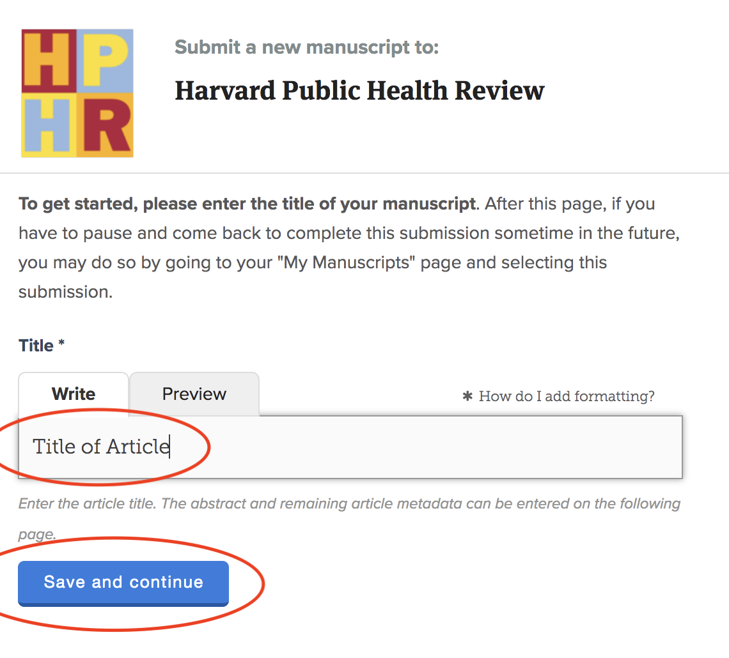

#### Step 3: Enter the Abstract and Keywords

Once you enter the title, you’ll be prompted to:

* Enter your manuscript’s abstract. If your piece does not have an abstract, please enter the first paragraph or a brief description.
* Provide keywords or descriptors

**Note**: To complete this step, opt  to “mark this step as complete” as indicated.

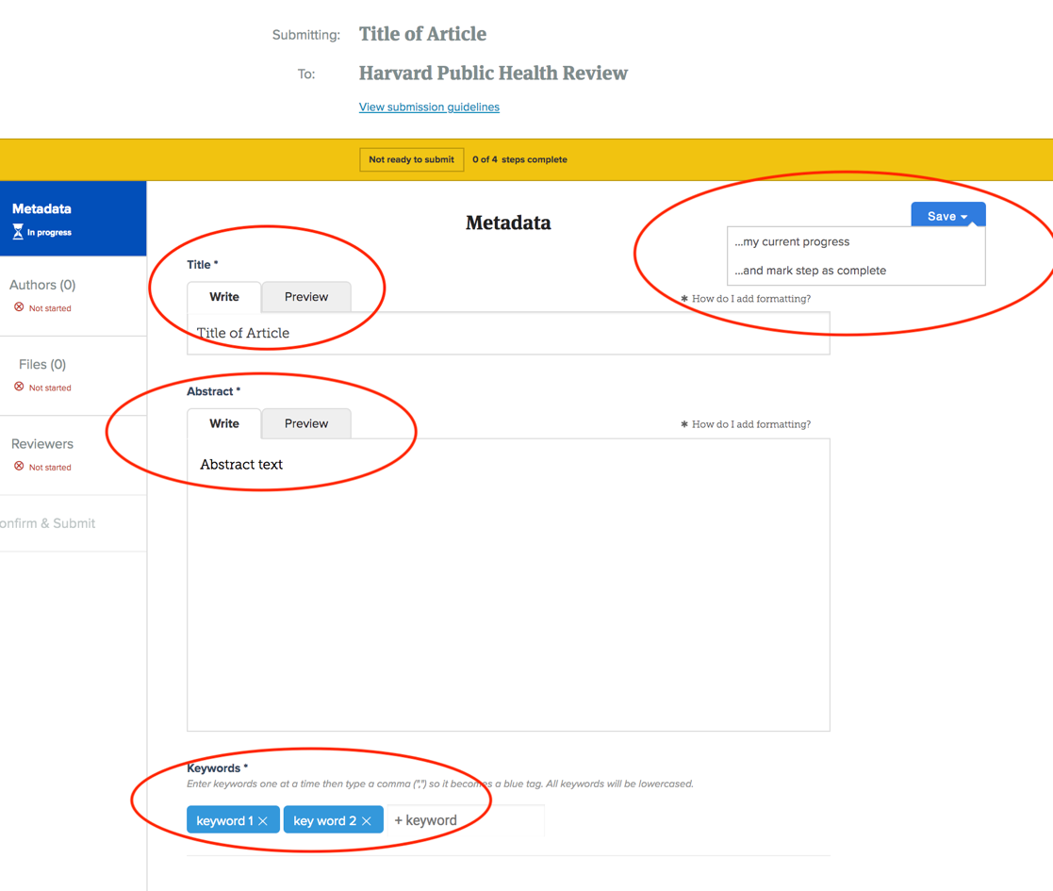

#### Step 4: Enter the Contact Author

You’ll then be prompted to add information for the authors. The first author name submitted should be the primary contact.

**Note**: This section requests optional demographic information, which helps us understand who has submitted to the Journal. It is not required.

When done, click the blue “Add Author” button.

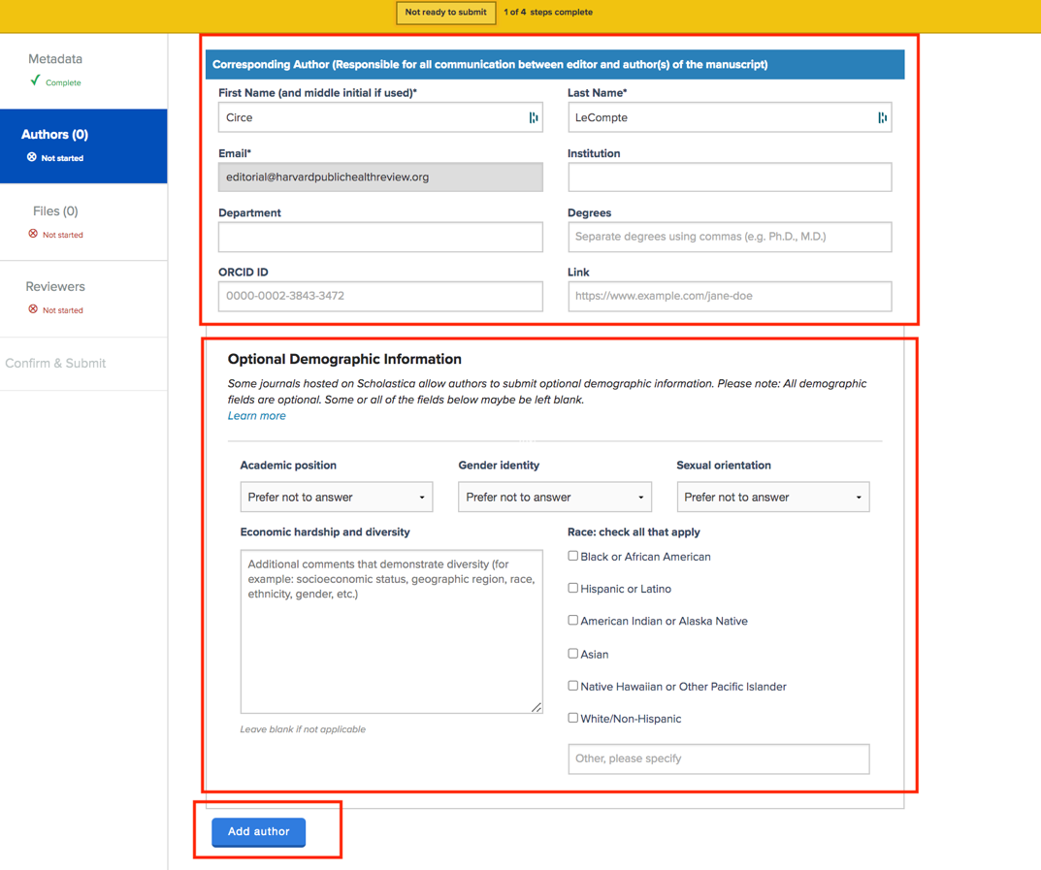

#### Step 5: Enter Additional Authors

If there are additional authors, add them after the contact by clicking the gray “Add Author” button.

**Note**: Please enter authors in order as much as possible here. Author order cannot be changed after submission. However, it can be updated prior to publication. (Scholastica is an editorial platform and not used for publishing.)

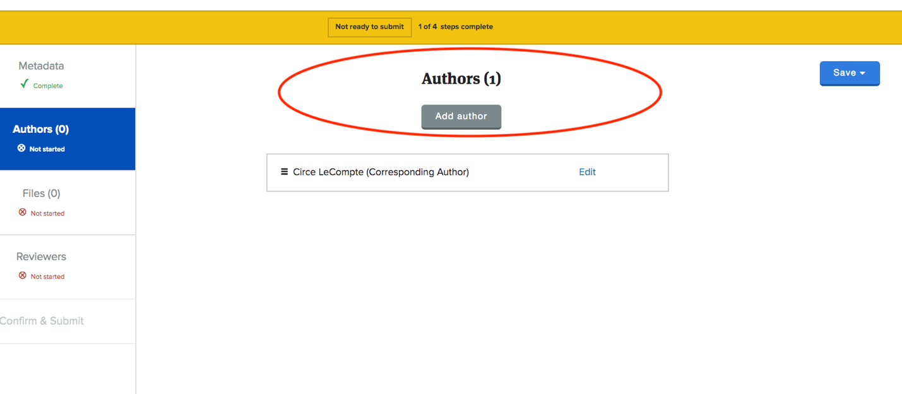

#### Step 6: Upload Your Manuscript Files

You’ll then be prompted to upload your manuscript file(s)  prepared according to HPHR‘s [Submission Preparation Guidelines](https://harvardpublichealthreview.org/how-to-submit-to-hphr/).

Please be sure that your primary  manuscript is in Word and aligns with all HPHR guidelines. Authors submitting media may upload additional files as well. Please be sure to submit only high resolution (300 DPI) images.

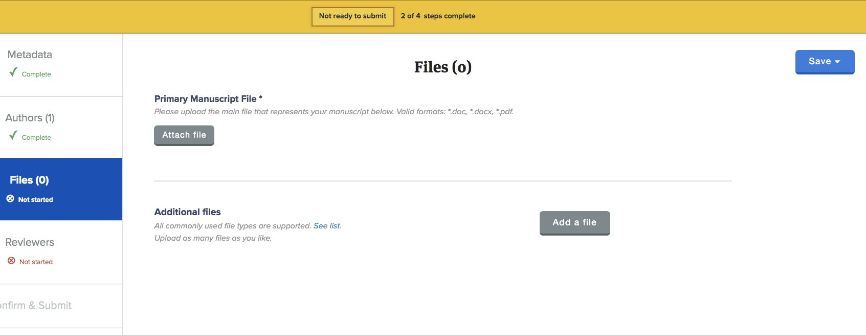

#### Step 7: Suggest Potential Reviewers

You’ll be asked to identify potential reviewers for your paper. This is an optional step. Please be sure NOT to suggest reviewers who informed the paper’s content.

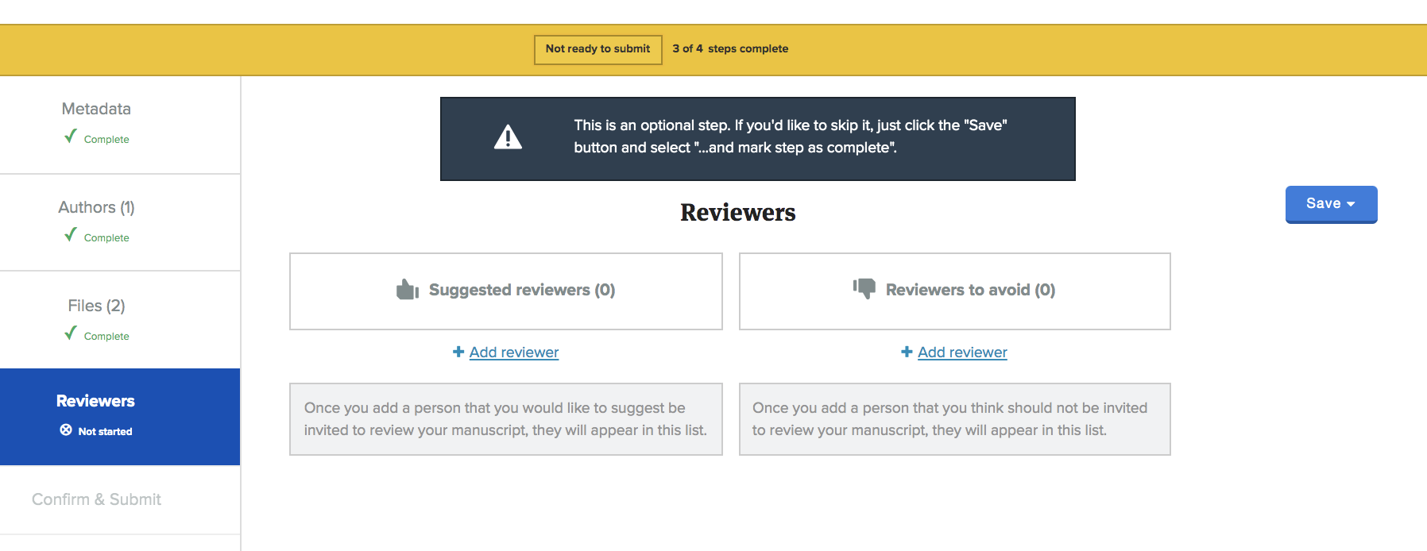

#### Step 8: Finalize Submission

With that, you can review your content and click submit.

