HPHR Revise & Resubmit Author Guidelines/Template

Submitting Your Revised Article
The Harvard Public Health Review (HPHR) is pleased to invite you to submit a revised version of your article based on peer-review feedback. To be considered further for publication, we request that you review and incorporate the comments from the reviewers and editorial staff and resubmit your manuscript to HPHR by the deadline indicated in the decision email you have received.

Materials are accepted via https://app.scholasticahq.com/login. Please submit your revised article files on Scholastica as an update to your original submission under the “Manuscript Details” page (do not re-submit your revised article as a new submission). See screenshot example below:
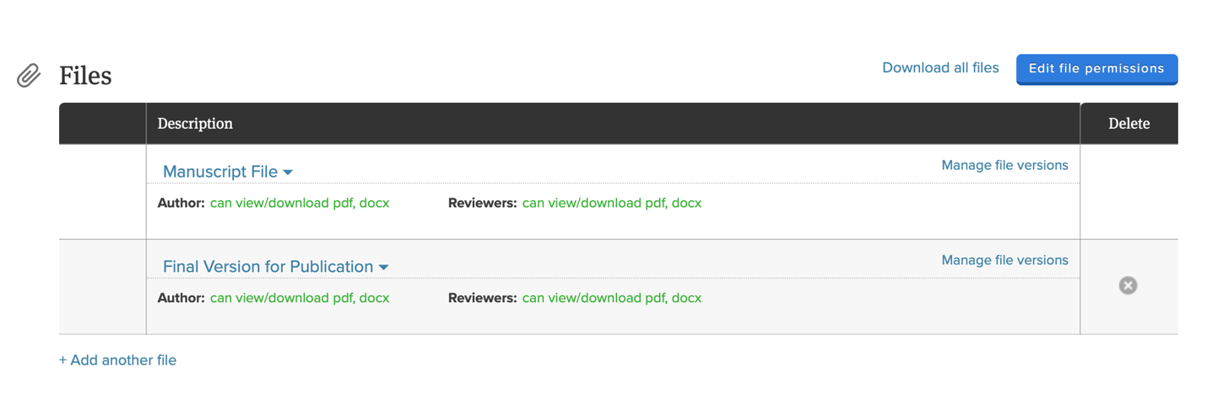

In addition, please notify your Editor that you have uploaded your revised materials using “Discussions” on Scholastica. See screenshot example below:

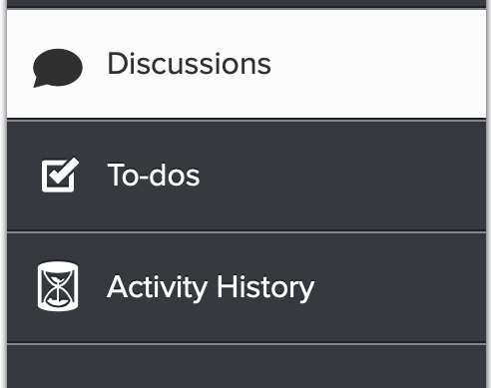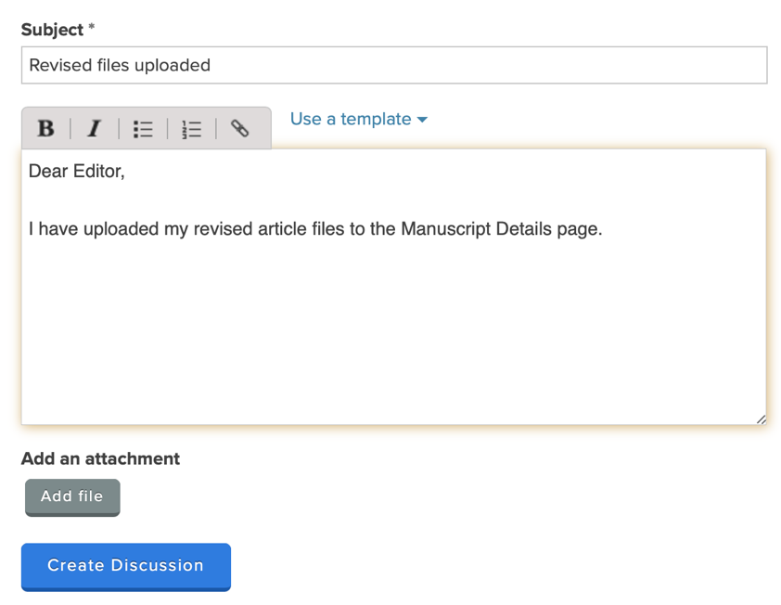

Revisions will generally be reviewed within a few weeks of submission. Please contact us via email (submissions@harvardpublichealthreview.org) if you have any questions about the revise and resubmit process.

Formatting and Re-submitting Your Revised Article
Please adhere to the following guidelines when submitting your revised manuscript and include:

- Your point-by-point response to each reviewer comment (see pages 3-4 of this document for our required template).

- Two versions of your revised article:
  - (1) A marked-up copy using Microsoft Word’s track changes (to indicate all changes made to the text), which will be used for editor purposes; and (2) A “clean” un-marked copy that has all changes “accepted,” which will be used by production should your manuscript be accepted.

  - Note: The two copies of your article should be identical and both copies should include all requested revisions. The “clean” copy should still contain all revisions reflected in the marked-up version, just with tracked changes “accepted.” Please included the term “revised” in your title and also include the date.

  - Please take this time to ensure all references are formatted in APA style. There are free reference managers (e.g., Mendeley or Zotero) that offer APA reference formatting.

These 3 document files (response to all reviewer comments, manuscript revisions “tracked”, and manuscript revisions “clean”) should be submitted as separate Word documents to Scholastica.

HPHR Revise & Resubmit Author Response Template

Revisions should include the response to all reviewer and editor comments detailing changes and explaining how each reviewer point has been addressed. Please copy-paste each reviewer comment into the template below and describe where modifications were made in your article. Please specify all sections of the paper (i.e., using page numbers and/or specific quotations) where changes have been made in response to reviewer comments. Note: please repeat the process for each set of reviewers’ feedback (i.e., if you received feedback from 2 reviewers, you should copy paste this template again and indicate “Reviewer 1” and “Reviewer 2” in order to address and respond to each review separately).

We look forward to reviewing your revised manuscript and encourage you to reach out if you have questions during the revision process. Thank you for submitting your work to HPHR!

Reviewer 1

Open response questions

Please note the importance and timeliness of the submission topic:
Copy-paste the reviewer feedback here.
Author response: type your rebuttal in bold font below their feedback here.

Is the content of this article appropriate for this journal?
Copy-paste the reviewer feedback here.
Author response: type your rebuttal in bold font below their feedback here.

What is the clarity and coherence of the author's(s') argument(s)?
Copy-paste the reviewer feedback here.
Author response: type your rebuttal in bold font below their feedback here.

Please comment on the quality of the empirical/qualitative evidence and/or theory/ies referenced in the submission:
Copy-paste the reviewer feedback here.
Author response: type your rebuttal in bold font below their feedback here.

Describe whether or not the article had appropriate/accurate, logical, and balanced presentation of the evidence used:
Copy-paste the reviewer feedback here.
Author response: type your rebuttal in bold font below their feedback here.

Discuss the organization, language and flow of the article:
Copy-paste the reviewer feedback here.
Author response: type your rebuttal in bold font below their feedback here.

Discuss the piece's implications for health, policy, and/or practice:
Copy-paste the reviewer feedback here.
Author response: type your rebuttal in bold font below their feedback here.

Comments to Author/Points the Author Should Consider to Strengthen Article:
Copy-paste the reviewer feedback here.
Author response: type your rebuttal in bold font below their feedback here.

